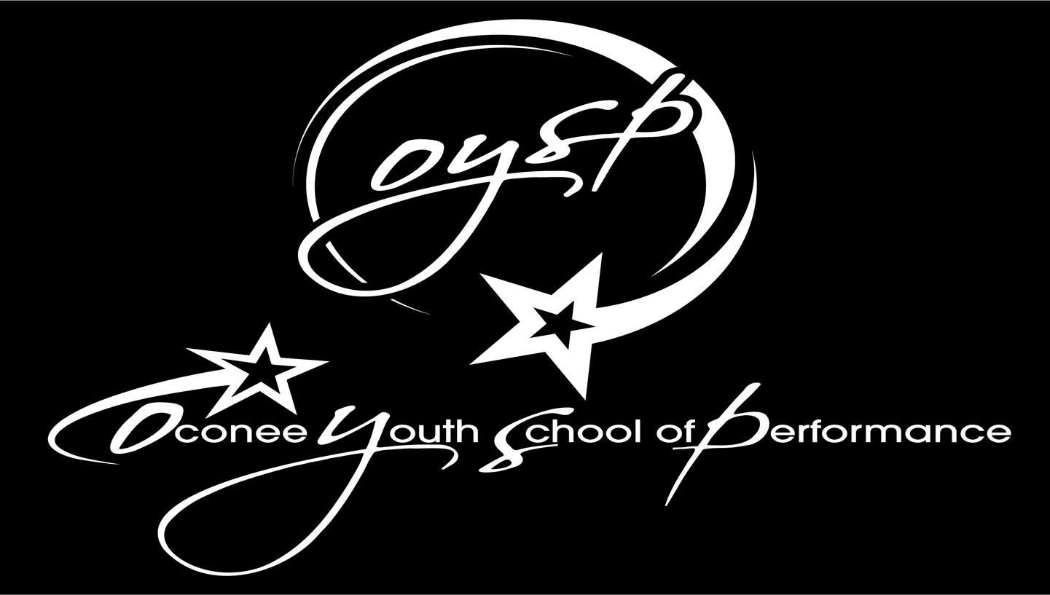
OYSP TUITION RATES 2026-27
HOURS PER WEEK | MONTHLY CHARGE
.05 hours | $70
.75 hours | $75
1 hour | $85
1.25 hours | $98
1.5 hours | $111
1.75 hours | $124
2.0 hours | $137
2.25 hours | $150
2.5 hours | $163
2.75 hours | $176
3.0 hours | $189
3.25 hours | $202
3.5 hours | $215
3.75 hours | $228
4.0 hours | $241
4.25 hours | $254
4.5 hours | $267

